RSA Public-Key Encryption and Signature Lab

NAME : JASHWANTH REDDY GANGULA  
SUID: 646254141

1. Introduction  
RSA is a public key cryptosystems used for secure communication. It first generates two large random prime numbers, and uses them to generate public and private keys, which can be used to do encryption, decryption, digital signature generation and verification. We try to implement RSA algorithm using C Programming Language.

2 Background

The numbers in RSA are generally 512 bits long. We cannot use regular +, * just like we use them on 32 or 64 bit numbers. We use libraries from openssl to perform arithmetic operations on integers of arbitrary size. To use library, we define each big number as BIGNUM type, and then use addition, multiplication, exponentiation, modular operations.

2.1 BIGNUM APIs

Library functions might need temporary variables, to store results or call recursively, using malloc for these variables might be expensive, so we use BN_CTX structure to create and hold BIGNUM temporary variables, and then pass them to the function.

BN_CTX *ctx = BN_CTX_new()

Initialize a BIGNUM variable  
BIGNUM *a = BN_new()

Assign a value from a decimal number string

BN_dec2bn(&a, "12345678901112231223");

// Assign a value from a hex number string

BN_hex2bn(&a, "2A3B4C55FF77889AED3F");

// Generate a random number of 128 bits

BN_rand (a, 128, 0, 0);

// Generate a random prime number of 128 bits

BN_generate_prime_ex (a, 128, 1, NULL, NULL, NULL);

2.2 Complete Example:

The below code is compiled and successfully executed to compute a*b, a^b(mod n) for big values of a and b.

/* bn_sample.c */

#include<stdio.h>

#include<openssl/bn.h>

#define NBITS 256

void printBN(char *msg, BIGNUM * a)

{

/* Use BN_bn2hex(a) for hex string

* Use BN_bn2dec(a) for decimal string */

char* number_str = BN_bn2hex(a);

printf("%s %s\n", msg, number_str);

OPENSSL_free(number_str);

}

int main()

{

BN_CTX *ctx = BN_CTX_new();

BIGNUM *a = BN_new();

BIGNUM *b = BN_new();

BIGNUM *n = BN_new();

BIGNUM *res = BN_new();

// Initialize a, b, n

BN_generate_prime_ex(a, NBITS, 1, NULL, NULL, NULL);

BN_dec2bn(&b, "273489463796838501848592769467194369268");

BN_rand(n, NBITS, 0, 0);

// res = a*b

BN_mul(res, a, b, ctx);

printBN("a * b = ", res);

// res = aˆb mod n

BN_mod_exp(res, a, b, n, ctx);

printBN("aˆc mod n = ", res);

return 0;

}

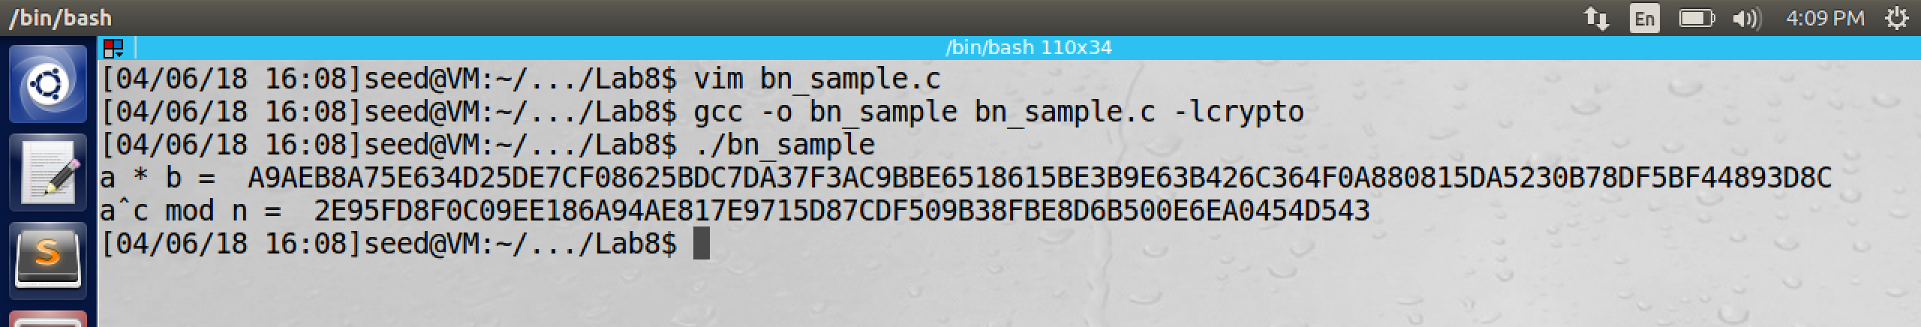

3 Lab Tasks

3.1 Task 1: Deriving the Private Key

Given,

p = F7E75FDC469067FFDC4E847C51F452DF

q = E85CED54AF57E53E092113E62F436F4F

e = 0D88C3  
We first calculate n = p * q;

we have to solve the equation e*d mod ((p-1) (q-1)) = 1. The program is as below.  
/* bn_sample.c */

#include <stdio.h>

#include <openssl/bn.h>

#define NBITS 256

void printBN(char *msg, BIGNUM *a)

{

/* Use BN_bn2hex(a) for hex string

* Use BN_bn2dec(a) for decimal string */

char* number_str = BN_bn2hex(a);

printf("%s %s\n", msg, number_str);

OPENSSL_free(number_str);

}

int main()

{

BN_CTX *ctx = BN_CTX_new();

BIGNUM *p = BN_new();

BIGNUM *p1 = BN_new();

BIGNUM *q = BN_new();

BIGNUM *q1 = BN_new();

BIGNUM *e = BN_new();

BIGNUM *d = BN_new();

BIGNUM *temp = BN_new();

BIGNUM *temp1 = BN_new();

BIGNUM *n = BN_new();

BIGNUM *n1 = BN_new();

BIGNUM *res = BN_new();

// Initialize p, q, n

// BN_hex2bn(&a, "2A3B4C55FF77889AED3F");

BN_hex2bn(&p, "F7E75FDC469067FFDC4E847C51F452DF");

printBN("p = ", p);

BN_hex2bn(&q, "E85CED54AF57E53E092113E62F436F4F");

printBN("q = ", q);

BN_hex2bn(&e, "0D88C3");

BN_dec2bn(&temp1, "1");

// compute n = p*q

BN_mul(n, p, q, ctx);

printBN("p * q = ", n);

BN_sub(p1, p, temp1);

printBN("p1 = ", p1);

BN_sub(q1, q, temp1);

printBN("q1 = ", q1);

BN_mul(n1, p1, q1, ctx);

printBN("p1 * q1 = ", n1);

// e*d mod ((p-1)(q-1)) = 1

BN_mod_inverse(d, e, n1, ctx);

printBN("d = ", d);

return 0;

}

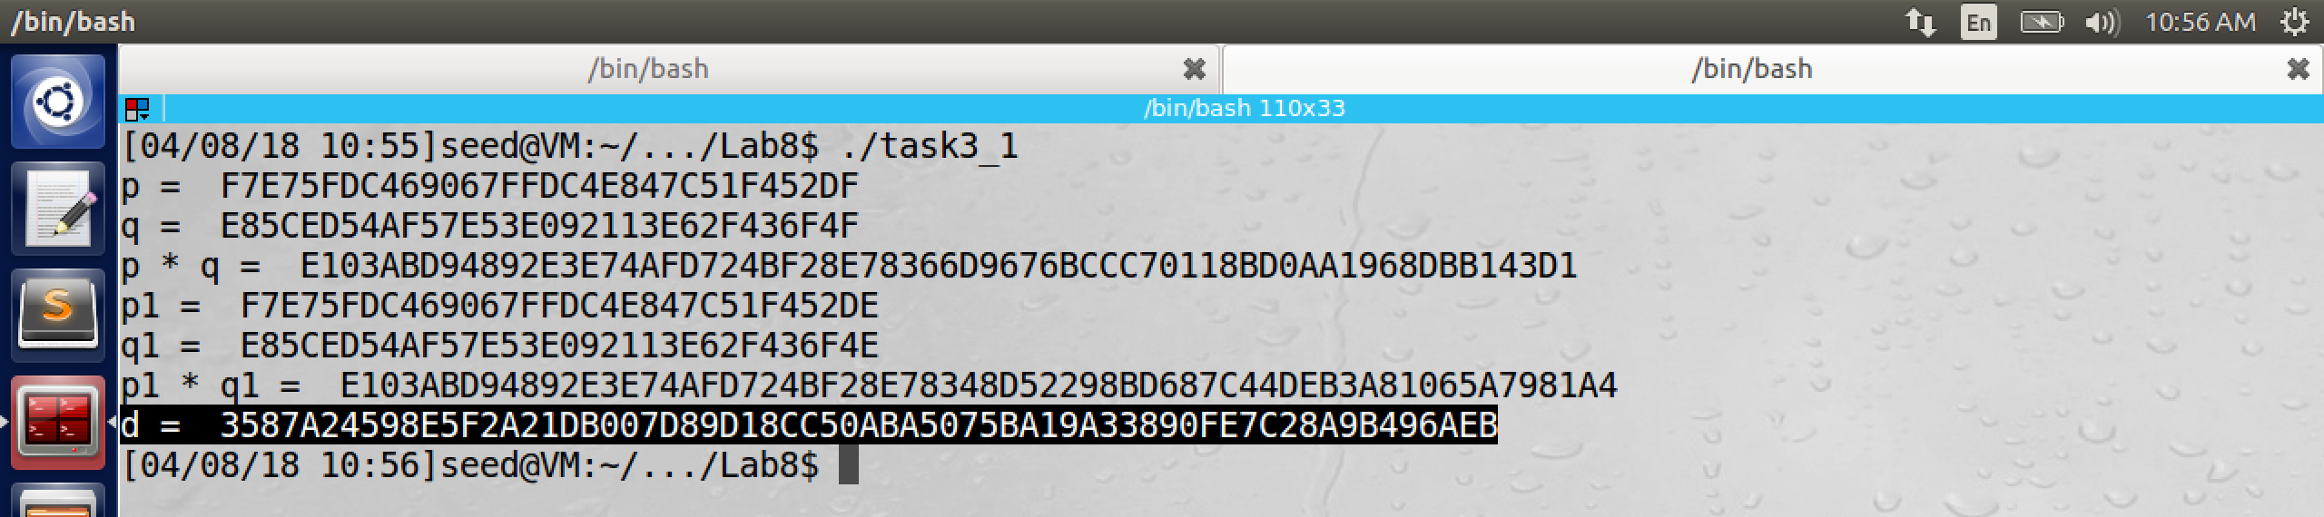

3.2 Task 2: Encrypting a Message

/* bn_sample.c */

#include <stdio.h>

#include <openssl/bn.h>

#define NBITS 256

void printBN(char *msg, BIGNUM *a)

{

/* Use BN_bn2hex(a) for hex string

* Use BN_bn2dec(a) for decimal string */

char* number_str = BN_bn2hex(a);

printf("%s %s\n", msg, number_str);

OPENSSL_free(number_str);

}

int main()

{

BN_CTX *ctx = BN_CTX_new();

BIGNUM *e = BN_new();

BIGNUM *d = BN_new();

BIGNUM *n = BN_new();

BIGNUM *res = BN_new();

BIGNUM *M = BN_new();

BIGNUM *cipher = BN_new();

BN_hex2bn(&M, "4120746F702073656372657421");

printBN("Message = ", M);

BN_hex2bn(&d, "74D806F9F3A62BAE331FFE3F0A68AFE35B3D2E4794148AACBC26AA381CD7D30D");

printBN("d = ", d);

BN_hex2bn(&e, "010001");

BN_hex2bn(&n, "DCBFFE3E51F62E09CE7032E2677A78946A849DC4CDDE3A4D0CB81629242FB1A5");

// cipher = M^e mod n

BN_mod_exp(cipher, M, e, n, ctx);

printBN("cipher = ", cipher);

// M = cipher ^ d mod n

BN_mod_exp(res, cipher, d, n, ctx);

printBN("Res = ", res);

return 0;

}

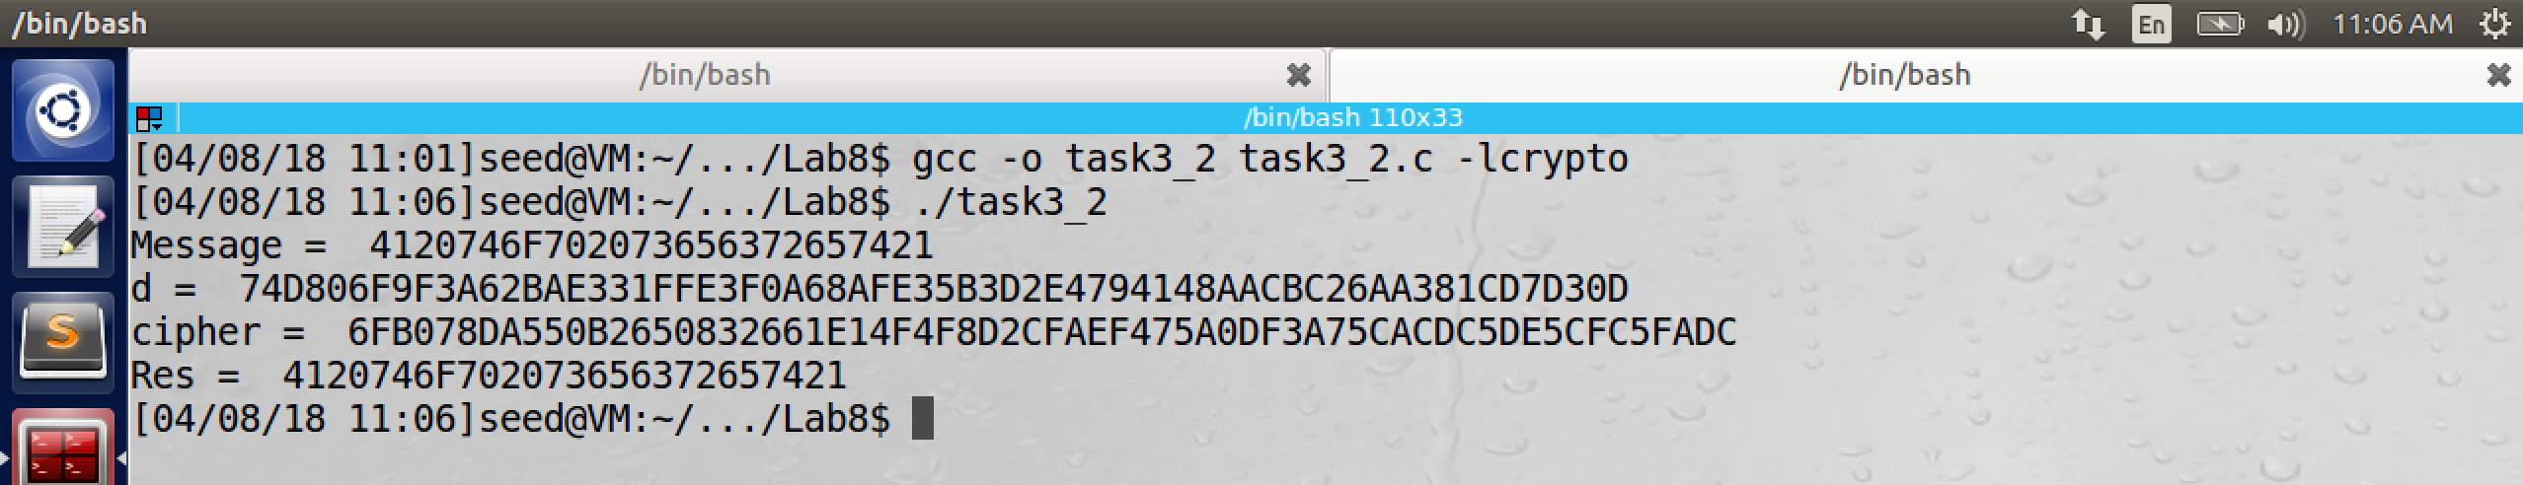

Please observe that result after decryption from cipher is same as the Message.

3.3 Task 3: Decrypting a Message

/* bn_sample.c */

#include <stdio.h>

#include <openssl/bn.h>

#define NBITS 256

void printBN(char *msg, BIGNUM *a)

{

/* Use BN_bn2hex(a) for hex string

* Use BN_bn2dec(a) for decimal string */

char* number_str = BN_bn2hex(a);

printf("%s %s\n", msg, number_str);

OPENSSL_free(number_str);

}

int main()

{

BN_CTX *ctx = BN_CTX_new();

BIGNUM *e = BN_new();

BIGNUM *d = BN_new();

BIGNUM *n = BN_new();

BIGNUM *res = BN_new();

BIGNUM *M = BN_new();

BIGNUM *cipher = BN_new();

BN_hex2bn(&cipher, "8C0F971DF2F3672B28811407E2DABBE1DA0FEBBBDFC7DCB67396567EA1E2493F");

BN_hex2bn(&d, "74D806F9F3A62BAE331FFE3F0A68AFE35B3D2E4794148AACBC26AA381CD7D30D");

printBN("d = ", d);

BN_hex2bn(&n, "DCBFFE3E51F62E09CE7032E2677A78946A849DC4CDDE3A4D0CB81629242FB1A5");

BN_mod_exp(res, cipher, d, n, ctx);

printBN("Res = ", res);

return 0;

}

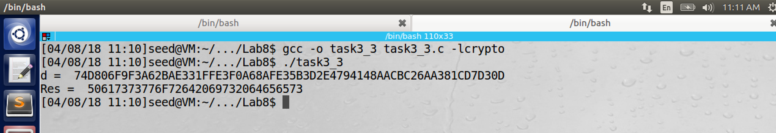

Now we decrypt the above hexadecimal message.



3.4 Task 4: Signing a Message

First we encode a message to be signed. We convert it to hexadecimal using the python script.



The program is as below.

/* bn_sample.c */

#include <stdio.h>

#include <openssl/bn.h>

#define NBITS 256

void printBN(char *msg, BIGNUM *a)

{

/* Use BN_bn2hex(a) for hex string

* Use BN_bn2dec(a) for decimal string */

char* number_str = BN_bn2hex(a);

printf("%s %s\n", msg, number_str);

OPENSSL_free(number_str);

}

int main()

{

BN_CTX *ctx = BN_CTX_new();

BIGNUM *e = BN_new();

BIGNUM *d = BN_new();

BIGNUM *n = BN_new();

BIGNUM *res = BN_new();

BIGNUM *M = BN_new();

// BIGNUM *cipher = BN_new();

BN_hex2bn(&M, "49206f776520796f75202432303030");

printBN("M = ", M);

BN_hex2bn(&d, "74D806F9F3A62BAE331FFE3F0A68AFE35B3D2E4794148AACBC26AA381CD7D30D");

printBN("d = ", d);

BN_hex2bn(&n, "DCBFFE3E51F62E09CE7032E2677A78946A849DC4CDDE3A4D0CB81629242FB1A5");

printBN("n = ", n);

// signature is (M^d mod n)

BN_mod_exp(res, M, d, n, ctx);

printBN("Res = ", res);

return 0;

}

Now we apply the signature to it, using the formula M^d(mod n) and the output is as below.

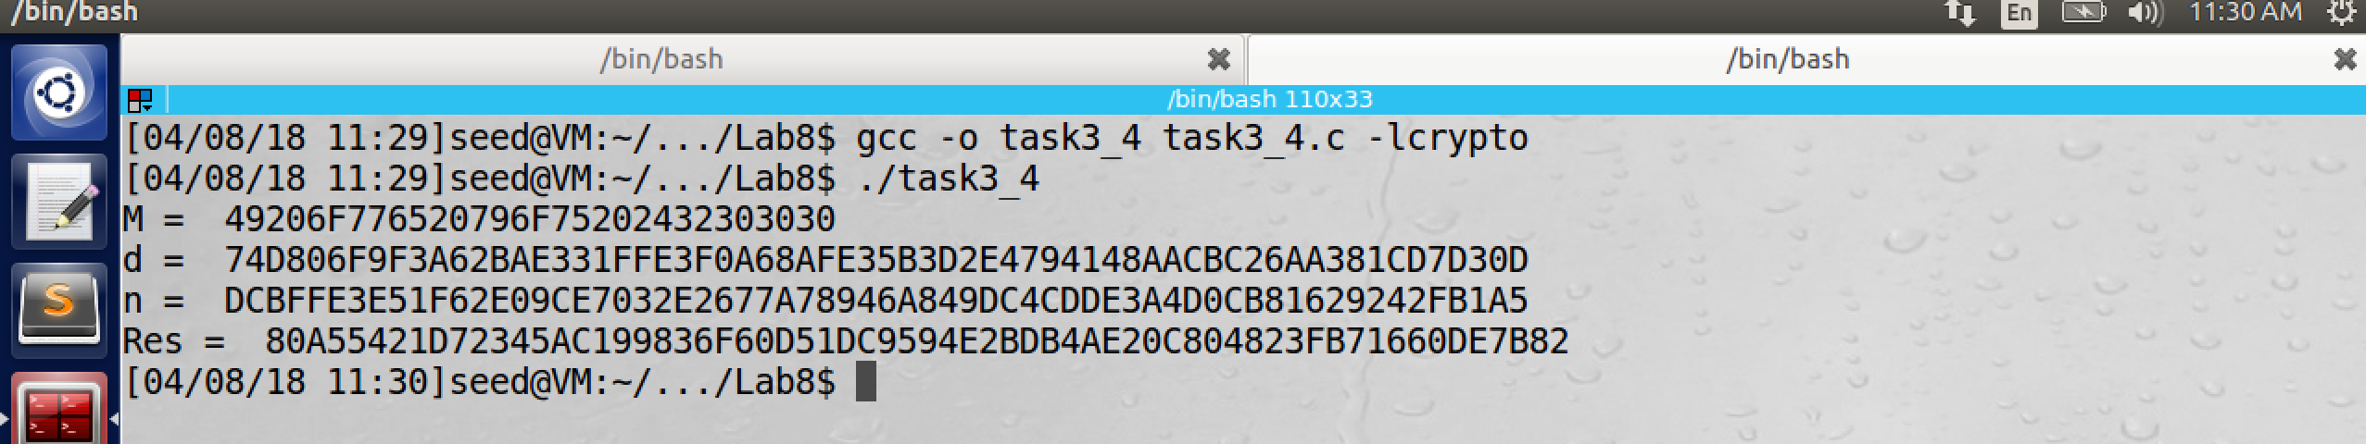

Now we change the message from $2000 to $3000 and observe the output



Now the result is significantly different from the previous one.

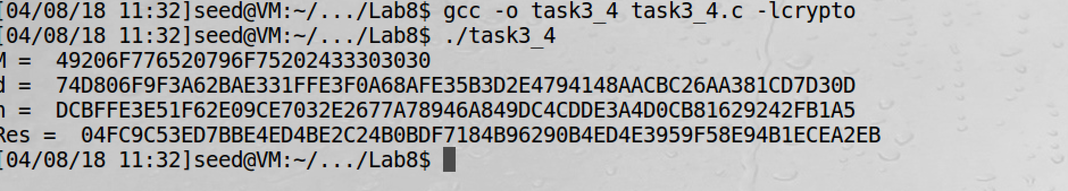

3.5 Task 5: Verifying a Signature

Bob receives a message M = "Launch a missile." from Alice, with her signature S. We know that Alice’s public key is (e, n). Please verify whether the signature is indeed Alice’s or not.

The public key and signature (hexadecimal) are listed in the following:

M = Launch a missile.

S = 643D6F34902D9C7EC90CB0B2BCA36C47FA37165C0005CAB026C0542CBDB6802F

e = 010001 (this hex value equals to decimal 65537)

n = AE1CD4DC432798D933779FBD46C6E1247F0CF1233595113AA51B450F18116115

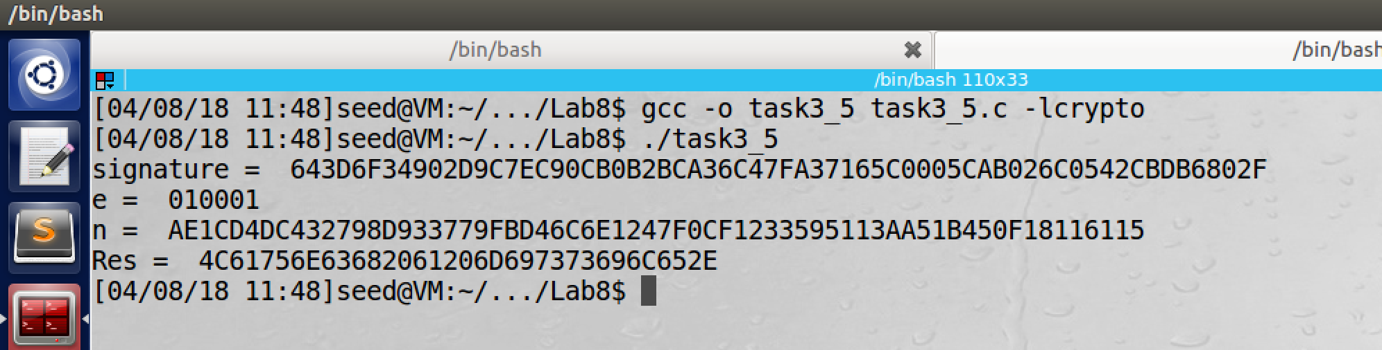



The message is correctly recovered from the signature, and hence signature is valid.

Now we change the last byte of the signature from 2F to 3F and the message cannot be recovered even if a single byte is corrupted.

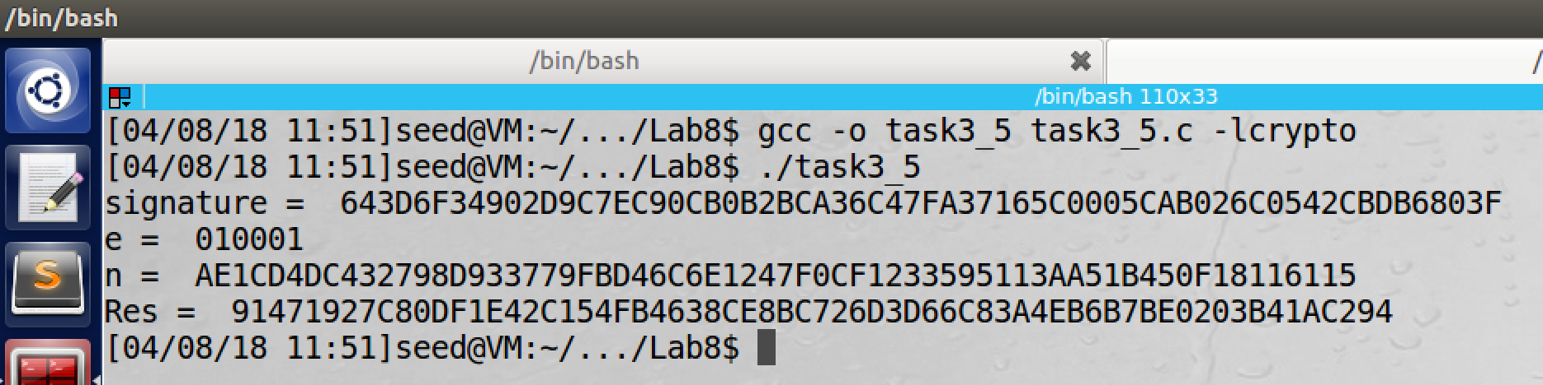



3.6 Task 6: Manually Verifying an X.509 Certificate

In this task, we need to verify a X.509 certificate using our program. It contains data about public key and issuer’s signature on the data. We will download a real X.509 certificate from web server, get its public key, and then use it to verify signature of certificate.

Fb.com’s certificate:

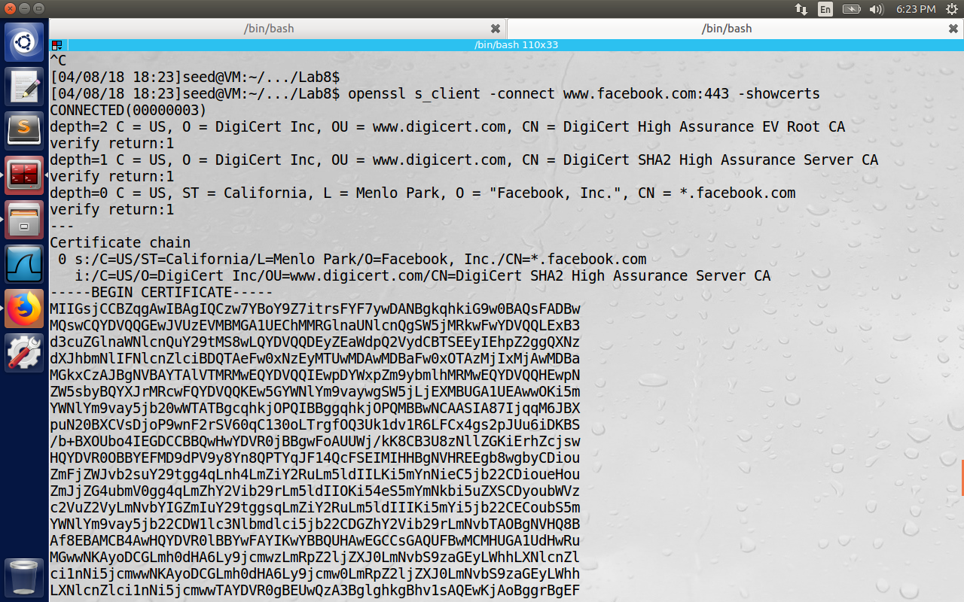

Issuer’s certificate:

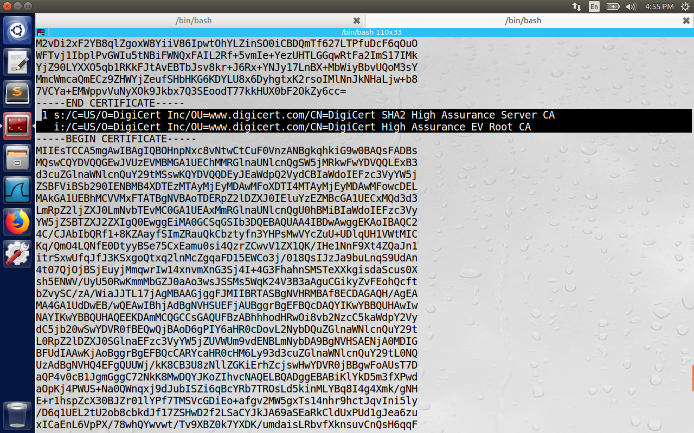

Step1: We use the [www.facebook.com](http://www.facebook.com) server in this document. The result of the command contains two certificates. The subject field(starting with s: ) is [www.facebook.com’s](http://www.facebook.com's) certificate.  
The subject field of the second certificate (highlighted in black above) is same as the issuer’s field of the first certificate. (The previous image field starting with i:)

The second certificate belongs to intermediate CA. In this task, we will use CA certificate to verify the server’s certificate.

Step 2: Extract the public key (e, n) from the issuer’s certificate

We copy the text between --BEGIN CERTIFICATE—and –END CERTIFICATE—to two files, let’s call them c0.pem and c1.pem.

openssl provides commands to extract certain attributes from x509 certificate.

We can extract the value of n using –modulus option.

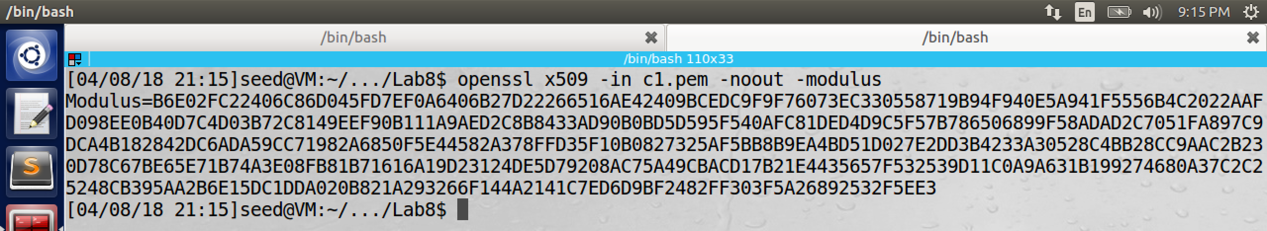

We can print all the fields and then extract e.

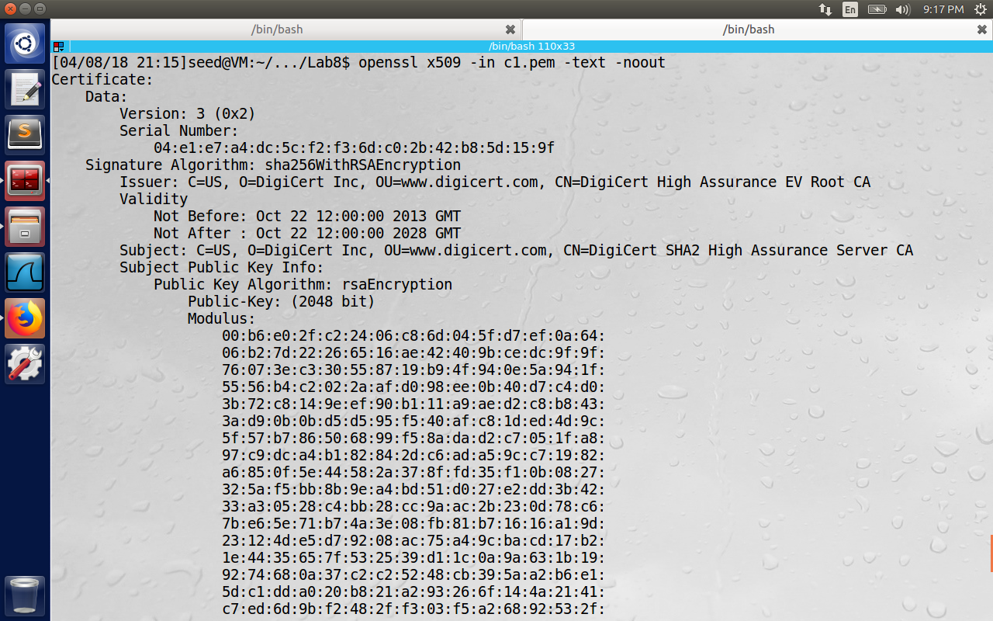

We can observe e in the highlighted text below. E = 65537  
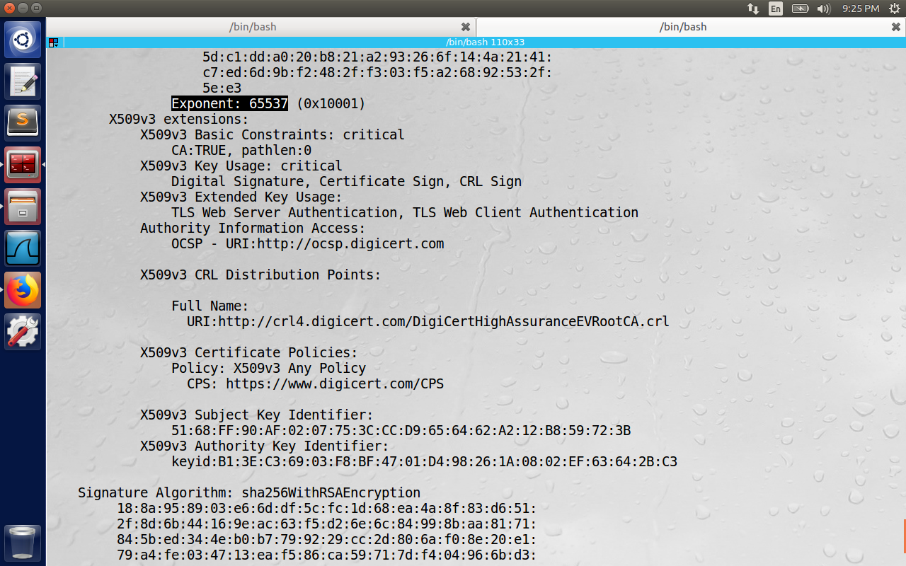

Step 3: Extract the signature from the server’s certificate  
There is no special command for signature, it is same as the previous command, we copy this signature to a file and use the Linux utility ‘tr’ to remove colon( : ) and space characters ( ‘ ‘ )

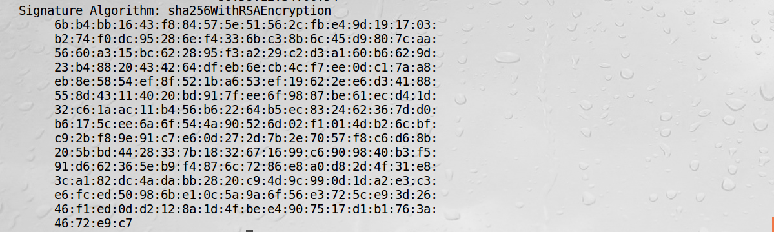

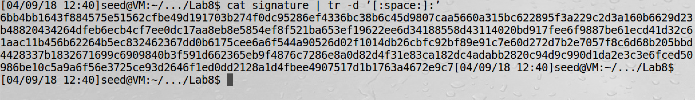

step 4: Extract the body of the server’s certificate

A Certificate Authority(CA) first computes hash of the certificate and then generates signature from the hash. we need to exclude the signature block before we compute the hash, openssl has a command called asn1parse, which can be used to parse x509 certificate.

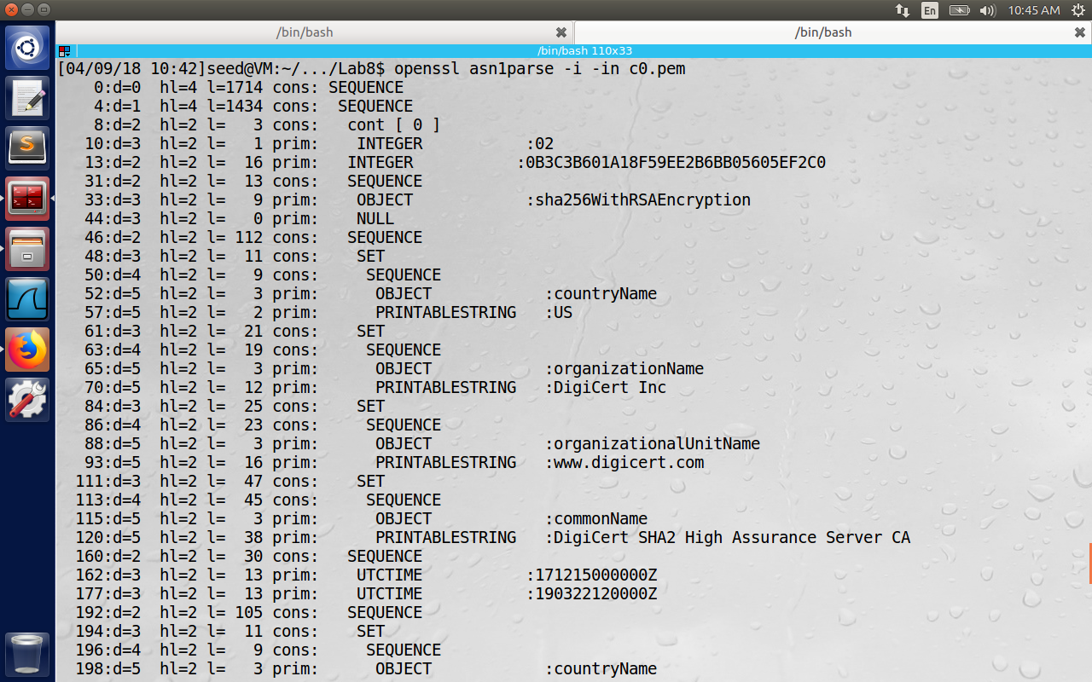

Now the starting of body is the sequence number 4 always as per the lab, but we need to use –strparse option to get the field from the sequence number 4 offset, to get the body excluding the signature, using the below command.

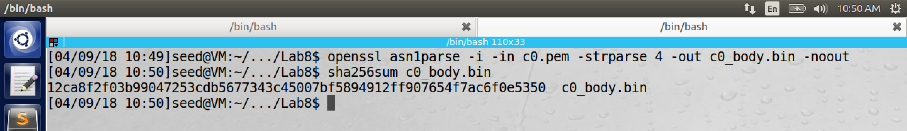

Step 5: Verify the signature

CA’s public key (e) = 65537

CA’s signature =



Hash of the CA’s body = 12ca8f2f03b99047253cdb5677343c45007bf5894912ff907654f7ac6f0e5350

Please observe the highlighted value in the below figure is same as the above hash of the CA’s body. Hence it is valid signature.

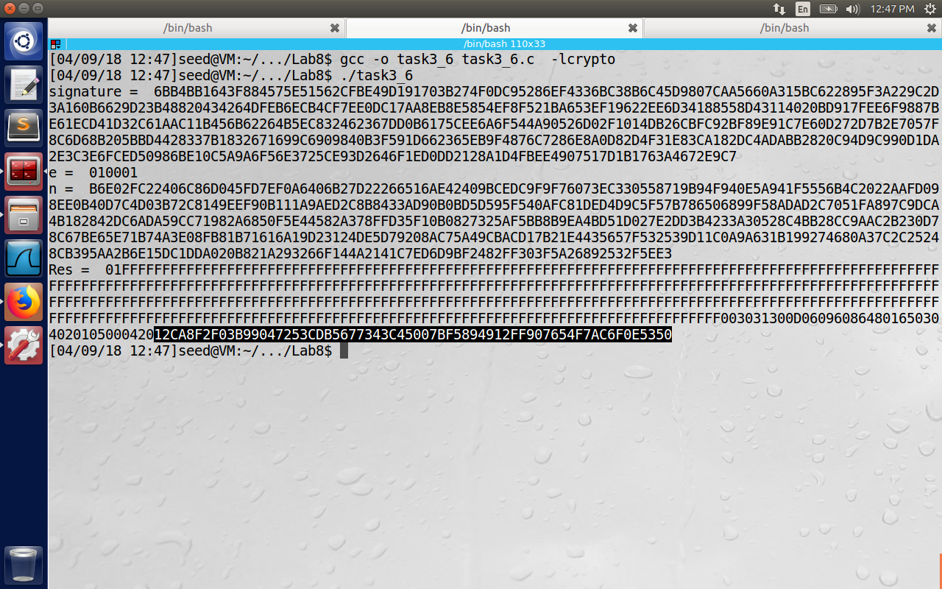

The program for it is as follows:

/* bn_sample.c */

#include <stdio.h>

#include <openssl/bn.h>

#define NBITS 256

void printBN(char *msg, BIGNUM *a)

{

/* Use BN_bn2hex(a) for hex string

* Use BN_bn2dec(a) for decimal string */

char* number_str = BN_bn2hex(a);

printf("%s %s\n", msg, number_str);

OPENSSL_free(number_str);

}

int main()

{

BN_CTX *ctx = BN_CTX_new();

BIGNUM *e = BN_new();

BIGNUM *d = BN_new();

BIGNUM *n = BN_new();

BIGNUM *res = BN_new();

BIGNUM *M = BN_new();

BIGNUM *signature = BN_new();

BN_hex2bn(&signature, "");

printBN("signature = ", signature);

BN_hex2bn(&e, "010001");

printBN("e = ", e);

BN_hex2bn(&n, "");

printBN("n = ", n);

// M^d mod n = signature.

// signature mod n = Message

BN_mod_exp(res, signature, e, n, ctx);

printBN("Res = ", res);

return 0;

}